

Post Newsletter  
June 2020

**Al Alford (Editor)**

**NOTICE TO MEMBERS:**

Greetings Members

Our Post has been closed since 18 March 2020. We will be re-opening Post 828 on 8 June 2020. Due to the average of age of our membership and its vulnerability, we gave special consideration for Post 828 members. The plan is to reopen the post gradually, rather than bringing all back at once. Basically, we are following local, state, and federal guidelines. Bottomline – no more than 56 patrons in the post at a time.

We will be opening the post at a 50% occupancy rate on 1 July 2020. The Executive Committee and other volunteers did a “Deep” cleaning and disinfecting the post for opening on 6 June @ 1000. We have put procedures in place as we gradually bring the post back to full operation over time.

A special thanks to the following members for their efforts to donate supplies and clean/disinfect the post in preparation for opening the post:

* Commander Al Alford
* 2nd Vice Commander Glenn Robinson
* Finance Officer Jerry Farmer
* Judge Advocate Burrell Parmer
* Service Officer Willie Watson Sr.
* Executive Committee Placement #2 – Thomas Hadley
* Auxiliary Vice President Joyce Williams
* Auxiliary Ida Allen
* Auxiliary & Bar Manager Sarah Kemper
* SAL DJ Bossman (Lee Johnson)
* Willie Watson Jr.

**Post 828 COVID-19 Procedures**

**(31 May 2020):** Post 828 Reopening Plan will include the following procedures:

* Individuals are expected to **wear masks** while in the post and maintain social distancing. We need to enforce strict social distancing protocols.
* **Internal Procedures:**
  1. There will be no hanging out or ordering at the bar
  2. Members will be seated at a table with no more than 4 people and tables must be 6 feet apart
  3. There will be no dancing until further notice
  4. Hand sanitizers will be at the door entry
  5. Encourage contactless payment
* The post will allow up to 50% of our occupancy capacity (112 patrons maximum). Once the city allows a higher occupancy rate, we will adjust accordingly. Due to limitation on occupancy rate, current (paid up) members have the priority for admission to post. Members are allowed 1 guest per member with strict compliance to sign in. Guests cannot add up to more than 10% of the occupancy rate. Please limit your guests to allow accommodating current members.
* We will put full security measures in place requiring our members to use the pin code or fingerprint to get in post [this will help limit patrons]. We will assign a member of the Executive Committee or other members to count entry and exit by Patrons. Members should have their cards with them at all time when visiting the post. If no Executive Member is present, bartenders will be **required** to check membership cards.
* The average age of Legionnaires is over 60 years. Many prefer to come to the post early and leave before sunset. **We will extend post hours to start at 2 pm.** Our license allows us to open as early at 1200. This will allow more senior members to enjoy the post and be home before “limited vision” comes into play.
* We are implementing policies to ensure working staff are symptom-free and at low risk for previous exposure to COVID-19.
* We will resume our monthly birthday celebrations and Blue Mondays on 1 July 2020 or when the bar occupancy rate is >50.

**Revised Post Hours:**

As noted earlier, due to advanced age of our average members, we are opening earlier to allow more senior members to enjoy the post and be home before “limited vision” comes into play (e.g., dusk dark or sunset): **(Note these hours are subject to change due to changes in the occupancy rate, economic considerations, and post policy).**

* **Monday**: 2:00 pm – 12:00 am
* **Tuesday**: Closed
* **Wed - Th**: 2 pm - 12 am
* **Fri - Sat**: 2 pm -1 am
* **Sun**: 4 pm – 12:00 am

***Flag Day***



This upcoming Sunday, June 14 is Flag Day. Flag Day is a special interest program for the American Legion. On June 14, 1777, the Second Continental Congress took a break from writing the Articles of Confederation and passed a resolution stating that “the flag of the United States be 13 stripes, alternate red and white,” and that “the union be 13 stars, white in a blue field, representing a new constellation.”

Here are some rules of Flag Etiquette:

* Many posts conduct Respectful burning of damaged flags according to established protocol each year
* According to the Flag Code, flying one upside-down is an official distress signal
* The Flag Code stipulates that the Stars and Stripes should not appear on apparel, bedding, or decorative items
* The practice of draping coffins in the American flag is not reserved for military veterans and government officials. On the contrary, any burial may incorporate this tradition.
* Etiquette calls for American flags to be illuminated by sunlight or another light source while on display.
* When flags are taken down from their poles, care must be taken to keep them from touching the ground. In fact, the American flag should always be kept aloft, meaning that rugs and carpets featuring the Stars and Stripes are barred by the Flag Code.
* The Flag Code strictly prohibits adding an insignia, drawing or other markings to the Stars and Stripes.

**Burial Flags:**

A United States flag is provided, at no cost, to drape the casket or accompany the urn of a deceased Veteran who served honorably in the U. S. Armed Forces. It is furnished to honor the memory of a Veteran’s military service to his or her country.

Generally, the flag is given to the next-of-kin, as a keepsake, after its use during the funeral service. When there is no next-of-kin, VA will furnish the flag to a friend making request for it. For those VA national cemeteries with an Avenue of Flags, families of Veterans buried in these national cemeteries may donate the burial flags of their loved ones to be flown on patriotic holidays.

A person may apply for the flag by completing VA Form 27-2008, Application for United States Flag for Burial Purposes. U.S. Post Offices are the primary issuing point for burial flags. Generally, the funeral director can help you obtain a flag. Call and confirm with the post office in advance. Not all local post offices have burial flags on hand, but they should be able to direct you to the closest issuing post office. Regional VA Offices can also help identify local issuing points.

**Displaying Burial Flags:**

The proper way to display the flag depends upon whether the casket is open or closed. VA Form 27-2008 provides the correct method for displaying and folding the flag. The burial flag is not suitable for outside display because of its size and fabric. It is made of cotton and can easily be damaged by weather.

**Donating Burial Flags:**

Most of the Department of Veterans Affairs national cemeteries display an Avenue of Flags on patriotic holidays and during special events. The Avenues consist of burial flags donated by the families of deceased Veterans and provide a unique visible tribute to all our Nation's Veterans.

A Certificate of Appreciation is presented to the donor for providing their loved ones' burial flag to a national cemetery. Please contact the cemetery of your choice for information on how to donate a Veteran's burial flag.

***Memorial Day Free Fried Fish Dinners***

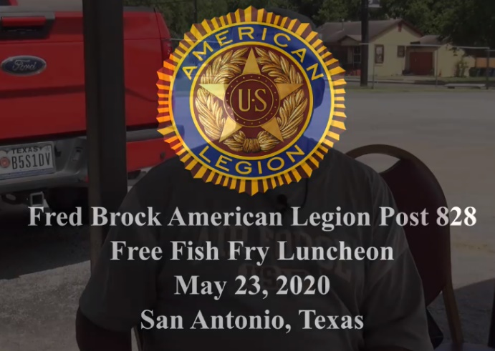(May 23, 2020) As The American Legion prepares to honor those brave men and women who have died serving in our U.S. Armed Forces and in honor of military, veterans, first responders, healthcare personnel, and the community-at-large, Fred Brock American Legion Post No. 828 provided free fish fry lunches at the Post from 11am – 1pm for drive-thru pickup. The Post served more than 200 meals to the community. Many thanks to the Executive Board and volunteers who supported the community give-back event. Special thanks to Grady Robinson of Tuskegee Airmen Inc * San Antonio Chapter for volunteering at Fred Brock American Legion Post 828's Free Fish Fry Luncheon held at the Post located on MLK Dr. on the city's East Side. He assisted in provided more than 200 meals to members of the community. Author - Burrell Parmer

**Legionnaire Willie Foster:**

Legionnaire Willie E. Foster Sr. passed away on April 9, 2020. He was born on April 17, 1922, to the parentage of Mack and Annie Foster in Fort Worth. Foster graduated from Wheatley High School and attended Cuney Elementary and Douglas Middle Schools. He joined the U.S. Army in 1942, serving during WWII. He was discharge from the Army in 1946 at the rank of sergeant (quartermaster). Afterwards, he worked on Fort Sam Houston Army Base, Kelly Air Field and at the Fort Sam Houston Hospital. Foster was a freemason with Star Tom Lodge No. 100 (Prince Hall Affiliated), an honorary past grand high priest (Holy Royal Arch Masons), a sublime prince of the Royal Secret with Lone Star Consistory No. 113, (Ancient & Accepted Scottish Rite), and a life member of Moussa Temple No. 106 (Prince Hall Shriners).

Prior to his memorial service, Foster remains were brought to Fred Brock American Legion Post as a final farewell to a great legionnaire. Post officers and members are masked due COVID-19 Health Crisis. Foster’s memorial service was held at Mt. Sinai Baptist Church officiated by Rev. Dr. Garry L. Roberts on April 17, which would have been Foster’s 98th birthday. As a World War II veteran, he is among few members honored in documentary about the Experience of Black Military Members in WW II.

**Figure 1 - Legionnaire Willie Foster pays one last visit to his beloved Post 828**

**Legionnaire James M. “Mouse” Hill:**

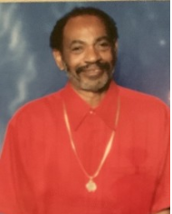Legionnaire James M “Mouse” Hill passed away on 30 May 2020. James O’Neal “Mouse” Hill was born on October 10, 1948 in Del Rio, Texas He attended G.W. Brackenridge High School- Class of 1966, where he participated in football, baseball, and track and field. After graduation, he joined the United States Air Force in 1967 where he served six years stationed in Athens, Greece as an USAF Postal Courier. He received The Air Force Commendation Medal for meritorious service from September 11, 1968 to May 20, 1971. Mouse later attended New York University (NYU) and University of Maryland where he received a Bachelor of Business Management degree. he joined the San Antonio Fire Department 624 in 1977 and later attended San Antonio College where he received an Associate in Applied Science- Fire Science degree. He would retire after 30 courageous years serving the community of San Antonio.

Active in the local community, Mouse was also an active member and a past president of the Queen of Soul organization for over 40 years. He was also active with the Masonic Lodge - affiliations included Alamo Lodge 1491, San Antonio Consistory #1, and Alkoran Shrine Temple #99. He was a 17-year member of Post 828. Buddy Hill was an US Air Force veteran and former member of the San Antonio Fire Department, “Mouse” was a member of the San Antonio Zulu Association and Masonic organizations.

**Legionnaire Hardy Burrell Jr:**

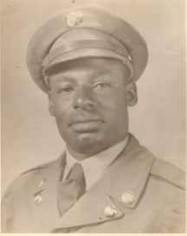Legionnaire Hardy Burrell Jr was born on July 8, 1928 in Pittsburg, TX. He attended school in Pittsburg, TX, and completed his education from Fredrick Douglas High School in 1946. After graduating from high school Hardy decided to continue his education. He attended St. Phillips College in San Antonio, TX but it was shortly interrupted due to him enlisting in the United States military. Hardy served his country during the Korean War from 1950 through 1952 and was a 12-year member of Post 828. Hardy passed away on May 21, 2020.

**Auxiliary Mary “JoAnn” Flint- Humphrey:**

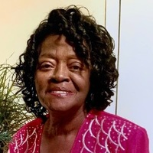Past American Legion Auxiliary Unit #828 President JoAnn Flint set the example, proud to serve as the President of the Auxiliary. Elected in June 2014 with the theme of "The Unit on The Move". She was a long-time active member since. She also served as Ladies-At-Large and Secretary. Jo Ann was born in San Antonio graduating from Phyllis Wheatley High School in 1964. She travelled extensively to many interesting places as a military wife. Jo Ann worked for Federal government for 34 years and 9 years with State government. She was an active member of Electa Chapter, Order of the Eastern Star OES), Charity Court, Jones Court AAODS, and the Government Girls Club. Jo Ann also served as President of the Phyllis Wheatley High School class of 1964. She is an active member of New Dimensions Church. Jo Ann was the proud, fulfilled mother of 3 children with 4 grandchildren and 4 great grandchildren.

**Auxiliary Jamesetta Grant:**

Jamesetta Grant was American Legion Auxiliary Unit #828’s Past President, 1st Vice President, sand Ladies-at-Large. Jamesetta was an active member of the American Legion Auxiliary for over 23, serving as President and other leadership positions. Jamesetta was born in San Antonio and attended the local schools before graduating from Phillis Wheatley High School in 1959. She began a career in the Insurance business in 1962 until retirement in 2002. For more than 38 years she has been an active member of Progressive Baptist Church. Jamesetta is also a member of Electa Chapter, Order of the Eastern Stars (OES). She was immensely proud of her 4 children, 11 grandchildren, and 7 great grandchildren. mother of 3 children with 4 grandchildren and 4 great grandchildren.

Place Holder

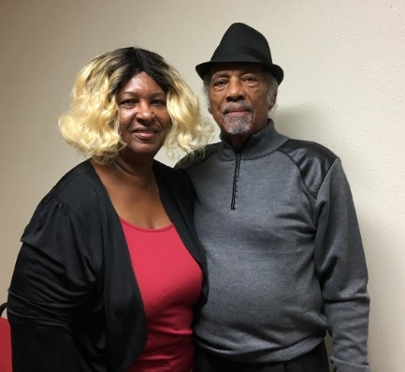** (23 May 2020) – Legionnaire Woodrow Wilson is an Army veteran who has quietly made major contributions to operations of Post 828. He is a 20-year American Legion member dedicated to helping the post. Woodrow and his wife, Rosa, are a constant presence at Post events, supporting all our programs.

***Member Spotlight***

Among the notable and consistent contributions of this dedicated member include:

* Coronavirus Donation ($500)

**Figure 2 - Legionnaire Woodrow Wilson with his wife Rosa (Auxiliary Member)**

* Building Fund “Gold Member”
* Attending services of Post 828 members moving to Post Everlasting
* Building shelving for the Post renovation
* Contributing to buying TVs for the post to keep **patrons informed about post activities**

***Post 828 Schedule of Events***

Listed below are the scheduled events for June 2020 through July 2020:

**June 2020**

* **June 1:** Blue Monday w/ DJ Boss Man (Executive Committee sponsored) - **Canceled Until Further Notice!**
* **June 6:** American Legion Riders Mtg (10) - **Canceled Until Further Notice!**
* **June 8:** Post 828 Re-opening (2 pm – 12 am)  
  Blue Monday w/ DJ Boss Man (Auxiliary sponsored) - **Canceled Until Further Notice!**
* **June 9:** **Post 828 - Executive Committee (6 pm) (Telecon)**
* **June 12:** June Birthday Celebration (8 pm) - **Canceled Until Further Notice!**
* **June 14**: **Flag Day**
* **June 14**: U.S. Army Birthday
* **June 21**: **Father’s Day**
* **June 22:** Blue Monday w/ DJ Boss Man (Legionnaires sponsored) – 7 pm - **Canceled Until Further Notice!**
* **June 24**: SQ 828 SAL - Regular Meeting (**To Be Determined**)!
* **June 29:** Blue Monday w/ DJ Boss Man (Legionnaire sponsored) – 7 pm **Canceled Until Further Notice!**

**July 2020**

* **July 4: American Legion Riders Mtg (10) [TBD]  
  July 4: Independence Day**
* **July 6:** Blue Monday w/ DJ Boss Man   
  (Executive Committee sponsored) – 7 pm [**TBD**]
* **July 8-12:** Department of Texas 101st   
  Anniversary Convention **Canceled Until 2021!**
* **July 10: July Birthday Celebration**
* **July 13:** Blue Monday w/ DJ Boss Man (Auxiliary sponsored) – 7 pm
* **July 13: Unit 828 Regular Meeting - 6 pm**
* **July 14: Post 828 - Executive Committee (6 pm) - [2nd Tuesday]**
* **July 20:** Blue Monday w/ DJ Boss Man **(S.A.L. sponsored)** – 7 pm
* **July 21: Post 828 Regular Meeting (7 pm)**
* **July 27:** Blue Monday w/ DJ Boss Man **(Legionnaire sponsored) – 7 pm**
* **July 25: SQ 828 SAL - Regular Meeting**

***Commander’s Corner***

It is critical that Post 828 follow the tenets of the American Legion as charted by congress in 1919. It is the primary mission of all organizations under the roof of Post 828 to support the mission of the American Legion. We should be one cohesive group with a singular purpose – support the mission of the American Legion.

I want to refocus us all on why we are here. In that spirit, I am issuing six (6) challenges for us all this upcoming year.

**Challenge 1: Leadership**: – The challenge is to all members is to support our post officers in their endeavors. Come to our meetings and make your opinions and ideas known.

**Challenge 2: Unity -** It is important for us to understand why we are here in the spirit of com-radeship and loyalty to your post – to its membership – to the state and national organizations. We must move away from any divisive “in fighting” and towards a unified effort to help this post continue to grow and thrive. The preamble to all our constitutions begins in the same manner “… For God and country we associate ourselves together for the following purposes… “; it boils down to all us should be united in support of the American Legion.

**Challenge 3: Participation -** Be Active in Your Post’s Affairs! Actively participate in post programs, meetings, and be a part of governance.

**Challenge 4: Learn About Your Legion -** Learn about the Legion. Not just for your own edification – instead, you can better articulate to potential members what we are all about and why they should belong to the American Legion.

**Challenge 5: Do the Right Thing -** Please abide by our house rules, by-laws, and rules adopted by our Post. Do not try to skirt the processes.

**Challenge 6: How Can I Help? -** We have a congressional charter from 1919 to provide services to veterans and the local community; support commemorative activities such as Memorial Day, Veterans Day, 4th of July; and Flag Day. They are part of the charter and why we are getting tax breaks. Come to the post and help us honor our veterans and be a part of our patriotic activities.

Let us make this the best year ever in the 74-year history of Fred Brock Post 828. Fall in where you fit in (officer, volunteer, etc.). Some of you will let my comments roll off and forget what was said and others will take it to heart and be a part of the progression. Which will you be? I look forward to seeing you at the post meetings!! Be safe!!

Regards:

**Al Alford**

**Post Commander**

***Post Leadership***

**American Legion**

**Commander** – Garnel E. “Al” Alford

**1st Vice Commander** – John Rogers

**2nd Vice Commander** – Glenn Robinson

**Adjutant** – Calvin Bateman

**Finance Officer** – Jerry Farmer

**Chaplain** – Patricia Wimberly

**Judge Advocate** – Burrell Parmer

**Historian** – Randal Glover

**Service Officer** – Willie Watson

**Sergeant-At-Arms** – Fernando Rover

**Executive Committee**:

**Placement 1** – Renee Pate

**Placement 2** – Tom Hadley

**Board of Trustees**:

6th Year - Keith Toney

5th Year - Charlie V. Landy (Chair)

4th Year - Calvin Young

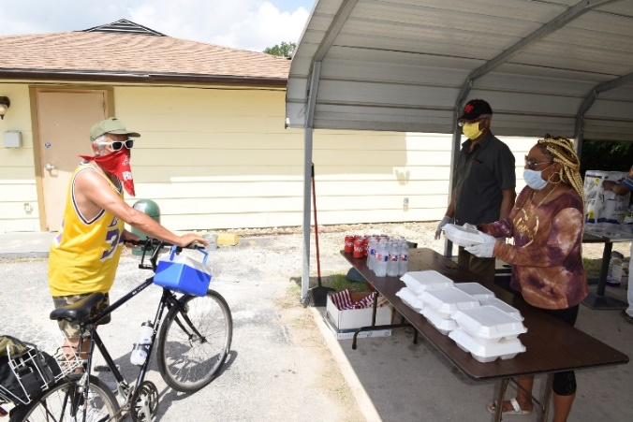3rd Year – Robert Allen

2nd Year – James Pearson

1st Year – Vacant

**American Legion Auxiliary**

**President** – Delores DeVaul

**1st Vice President** – Vacant

**2nd Vice President** – Reba Bennett

**Recording Secretary** – Annie Ross-Hinton

**Financial Secretary** – Lois Oliver

**Treasurer** – Pamela Flint-Money

**Figure 3 - (L to R) Glenn Robinson and Lynette Mackritis serving Fried Fish meal to resident of community**

**Chaplain** – Gloria Harper

**Historian** – Joyce Williams

**Sergeant-At-Arms** – Angela Mays

**Ladies-At-Large**

Vacant) Cora Clay

Jean Lampkin



**Sons of the American Legion**

**Commander** - Thomas Tyler

**1st Vice Commander** – Willie Watkins

**2nd Vice Commander** – Leonard Fuller

**Adjutant –** Richard Glover

**Treasury** – Frank Jones

**Historian** – Ed Glover

**Chaplain** – Eddie Douglas

**Sergeant-At-Arms** – James McCoy

**Squadron Advisor** – Jerome Harris



**American Legion Riders**

**Director** - Thomas Tyler

**Asst Director** – Willie Watkins

**Secretary –** Sarah Kemper

**Road Captain** – Effrain Rocha

**Treasurer** – Frank Jones

**Sergeant-At-Arms** – Tom Hadley

**Safety Officer** – Tom Hadley

***Free Fish Fry Luncheon  
Memorial Day Weekend***

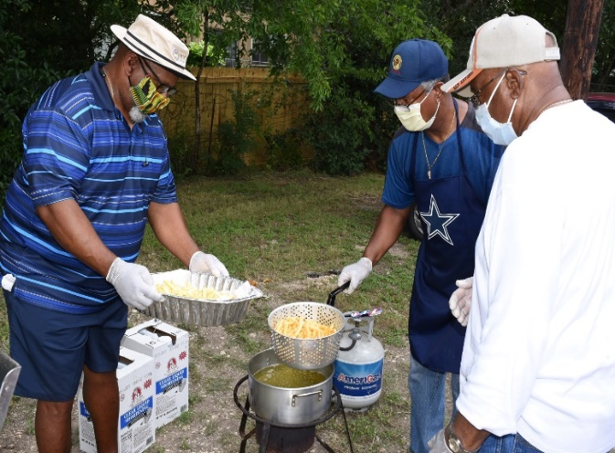

**Figure 4 - (L to R) Randall Glover, Glenn Robinson & Grady Robinson Frying Fish**

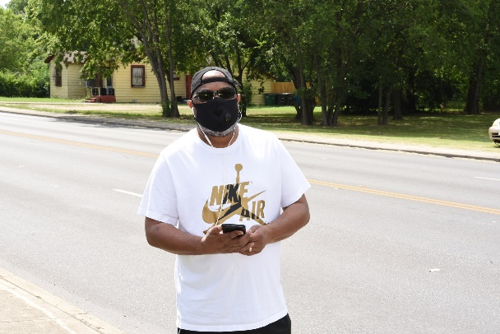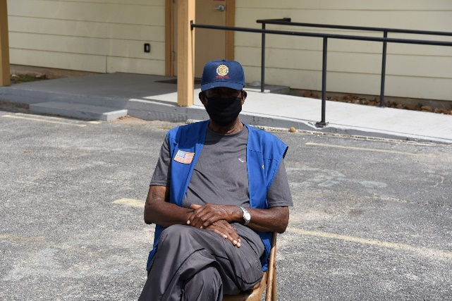

**Figure 5 - (L to R) Willie Watson and Fernando Rover managing traffic flow for Fried Fish Dinner**

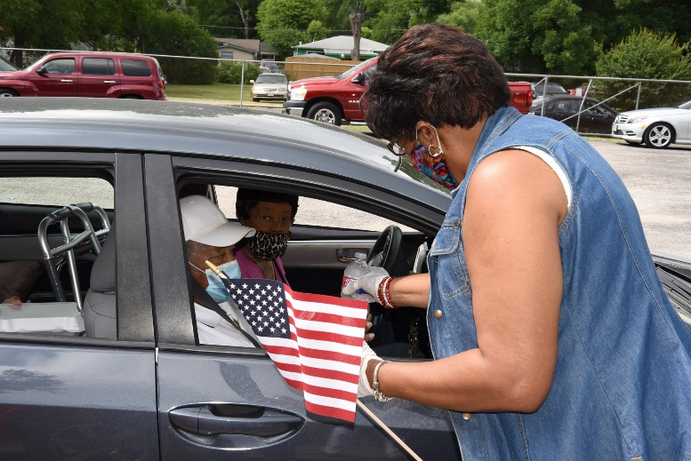

**Figure 6 – Pat Wimberly passing out flags to Veterans @ Memorial Day 2020 Free Fish Fry Dinner**

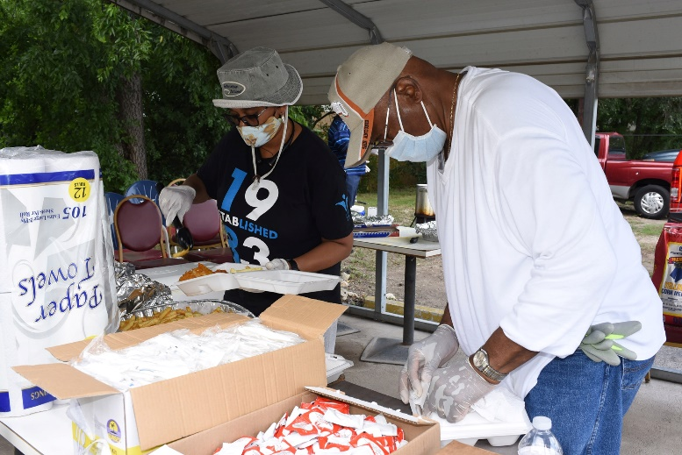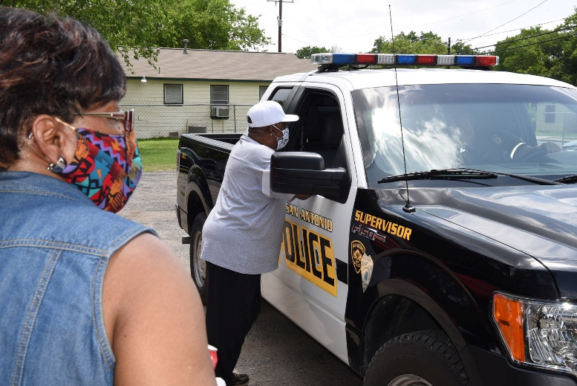

**Figure 7 – First Responder picking up free Fried Fish meal.**

**Figure 8 – Renee Pate-Hadley & Grady Robinson preparing dinner plates @ Memorial Day 2020 Free Fish Fry Dinner for Veterans, First Responders, and the Community**

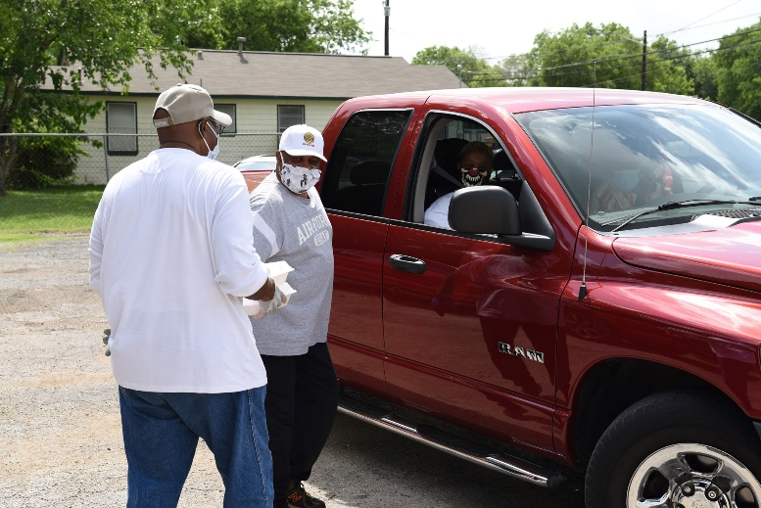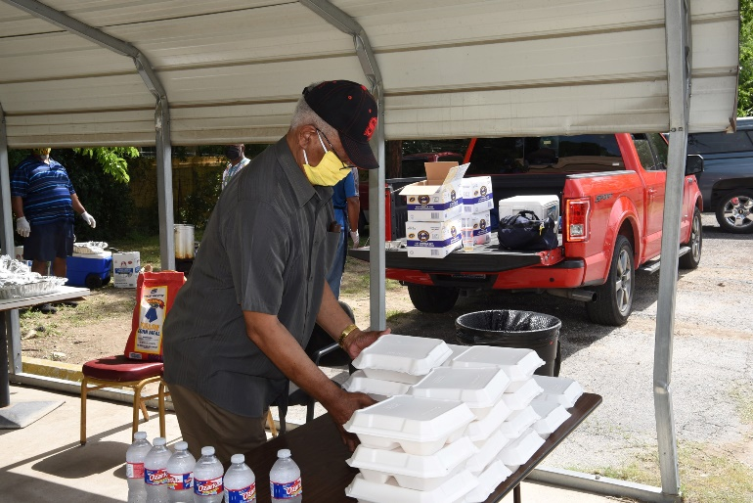

**Figure 3 - Calvin Bateman prepares fried fish lunches**

**Figure 4 – (L to R) Grady Robinson & Al Alford passing out dinners & flags to Veterans @ Memorial Day 2020 Free Fish Fry Dinner**

***Monthly Birthdays***

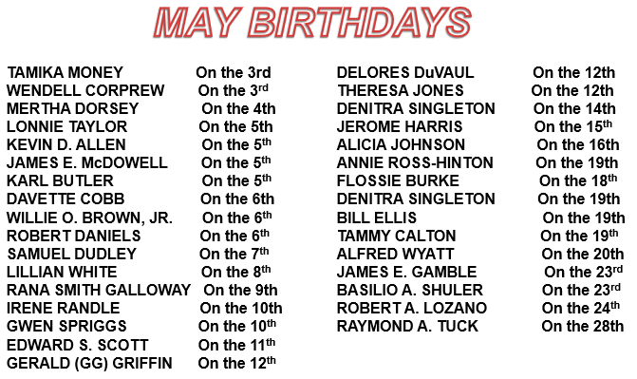

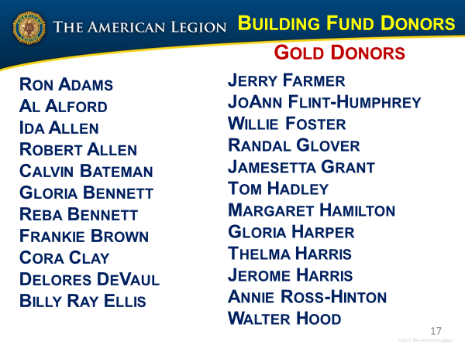

***Building Fund***

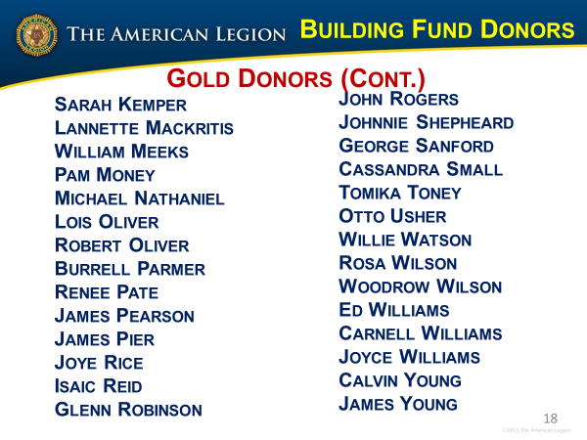The COVID-19 Health Crisis closed post operations in Mid-March. Unfortunately, all our bills did not take a break. We owe a great debt of gratitude to the following members for donating funds to pay our bills and keep the post operating

**Al Alford ($600)**

**Bill Merrill & Taunya Spells ($100)**

**Burrell Parmer ($200)**

**Calvin Bateman ($100)**

**Calvin Young ($300)**

**Carnell & Joyce Williams ($50)**

**Delores DeVaul ($40)**

**Glenn Robinson ($200)**

**Grady Robinson ($100)**

**John Rogers ($120)**

**Lois Oliver ($100)**

**Otto Usher ($200)**

**Pat Wimberly ($400)**

**Reba Bennett ($400)**

**Robert Allen ($200)**

**Robert Oliver ($100)**

**Rodney Watson ($100)**

**Rogers Reece ($100)**

**William “Killer” Martin ($100)**

**Ida Allen ($300)**

**Johnnie Shepheard ($100)**

**Renee Pate- & Tom Hadley ($200)**

**Jerry Farmer ($1850 – Post   
 Liquor License)**

**Donald Smothers ($50)**

**Lannette Mackritus ($50)**

**Pam Money ($200)**

**Willie Watson ($200)**

**Woodrow & Rosa Wilson ($500)**





***Coronavirus Fundraiser***

Fred Brock Post 828 has established a Veteran’s Memorial to honor veterans and their service to the country. Veterans and their family can honor the service of the brave men and women who have selflessly served our country and risked their lives to protect our freedoms. America’s Veterans have done everything asked of them in their mission to serve our country. Honor them or yourself with a name plaque on the Fred Brock Post 828 Veterans Memorial wall. The cost is only $50

**Information Needed:** Contact Ron Adams, Otto Usher, Jerry Farmer, or any Executive Committee officer for more information or to get a copy of the brochure containing application information.

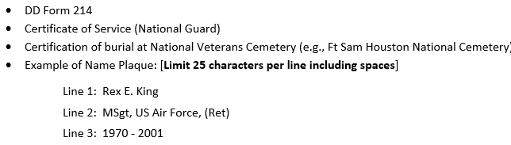

Make Checks Payable to:

***Veterans Wall of Honor***

Fred Brock Post 828

3415 Martin Luther King

San Antonio TX 78220

(210) 223-0636

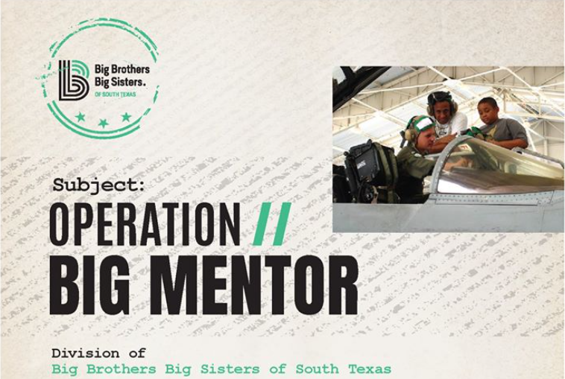

On behalf of the Military Mentoring Advisory Council of Big Brothers Big Sisters of South Texas, I would like to bring to your attention to a new initiative the organization has launched: **Operation: Big Mentor**. This mission is a volunteer recruitment effort with a goal to recruit 100 military volunteers to serve as mentors over 100 Days of Summer.  See Judge Advocate Burrell Parmer for more information (majparmer@gmail.com).

****<https://www.bigmentor.org/operation-big-mentor/> [#BigMentor](https://www.facebook.com/hashtag/bigmentor?__eep__=6&epa=HASHTAG)

***Member Spotlight***

Delores DeVaul is American Legion Auxiliary Unit #828 President for 2019-2021.  Delores is a proud mother of 4 children and a proud grandmother of 1 grandson.  One son is a Marine Veteran and daughter is an Air Force 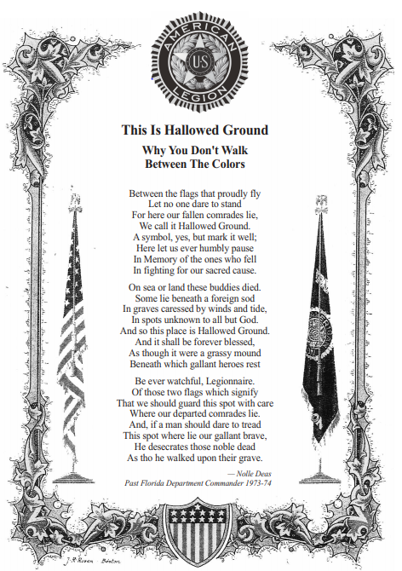Veteran and joining the American Legion in May 2018 through her brother Navy Veteran Leroy Burks.  Born and raised in Rockford, IL.  Lived in 2 other countries and home has been the San Antonio area for more than 17 years.

Entrepreneur, Broker/Owner of MyLegacy Realty, LLC, which is family owned and operated for more than 12 years. Delores is a Real Estate Broker, Property Manager and Real Estate Investor.  Member of Veteran's Association of Real Estate Professionals and of San Antonio Board of Realtors.  2011 President of San Antonio Association of Real Estate Brokers.  Member of Resurrection Baptist Church for 16 year.

Hobbies and activities for the past 3 months, gardening, making face masks, crocheting, hitting golf balls at the driving range, walking, and reading.

